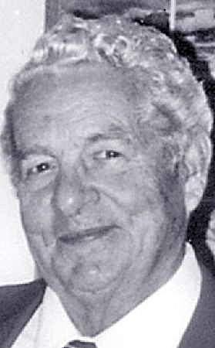

William Henry Somes 1921-2007

William Henry (Bill) Somes was born on Nov. 15, 1921 in Terre Haute, Indiana. He died at age 85 on Aug. 31, 2007 at the Bloomington Hospital in Bloomington, Monroe, Indiana

His parents were William Henry Somes, Sr. and Helena (Drummond) May. He was raised in Bloomington, Indiana by his great aunt and uncle, Oscar and Lizzie Hendrix.

Bill graduated from Bloomington High School in 1939, where he was a track star and member of the Thespian Club. He served in the Army Air Corps from December of 1943 to March of 1946. In 1949 he received his Bachelor’s Degree from Indiana University and did his post-graduate work in Business.

Prior to his retirement he was a Sales Representative for Best Beers. He was a member of Monroe Lodge #22, F. & A.M., Scottish Rite Valley of Indianapolis, Murat Shrine of Indianapolis, Elks Lodge #446, Burton Woolery Post #18 of the American Legion and the First Christian Church of Bloomington. He was an Army Air Corps veteran of World War II.

Bill was an avid reader (especially history and civil wars), who loved classical music, nature and long walks. He joined the YMCA when it first opened here. Having such an out-going personality, he never seemed to meet a stranger.

Survivors include his wife, Margaret “Peggy” (Sparks) Somes, one daughter and son-in-law, Sheron and Warren Ralph of Bloomington, two sons and daughters-in-law; Grant and Brenda Somes of Memphis, TN and Roger and Diana Somes of Bloomington, six grandchildren; Anthony Somes, Joshua Somes, Eric Somes, Evan Somes, Natalie (Dillon) Caldwell and Meghan (Somes) DeBeukelaer, four great grandchildren; Corey and Seth Caldwell and Brennen and Alison Somes, one half-sister, Rosemary Lantis of Ospalika, Alabama and two half-brothers, Richard May of Munster, In and Elmo May of Hebron, IN.

He was preceded in death by his parents, one brother, Oscar Joe “Tince” Somes.

